Rules for Linear Combinations of Random Variables

Suppose $X$ and $Y$are two random variables, such that $X$ has mean $μ_{x}$and standard deviation $σ_{x}$, and $Y$has mean $μ_{y}$and standard deviation $σ_{y}$.
- The mean of $aX±b$ is $aμ_{x}±b$
- The variance of $aX±b$ is $a^{2}σ_{x}^{2}$
- The mean of $X±Y$ is $μ_{x}±μ_{y}$
- The variance of $X±Y$ is $σ_{x}^{2}+σ_{y}^{2}$

In General: the mean of $ax±by±c$ is $aμ_{x}±bμ_{y}±c$
the variance of $ax±by±c$ is $a^{2}σ_{x}^{2}+b^{2}σ_{y}^{2}$

ex.) Let $X$be a random variable with mean $μ_{x}=5$and standard deviation $σ_{x}=3$
Let $Y$ be a random variable with mean $μ_{y}=7$ and standard deviation $σ_{y}=2$
Find the mean and standard deviation of $4X-3Y+1$.

$$μ_{4X-3Y+1}=4μ_{x}-3μ_{y}+1=4\left(5\right)-3\left(7\right)+1$$
$$=20-21+1=0$$

$$σ_{4X-3Y+1}^{2}=4^{2}σ_{x}^{2}+3^{2}σ_{y}^{2}=16{\left(3\right)}^{2}-9{\left(2\right)}^{2}$$
$$=16\left(9\right)-9\left(4\right)=144-36$$
$$=108$$
$$σ_{4X-3Y+1}=\sqrt{108}$$

Binomial Distribution
If the following conditions are met:
1.) A random process is repeated for a fixed number of trials, $n$
2.) Each trial has 2 possible outcomes, which we call success and failure.
3.) The probability of success is the same for every trial, $p$
4.) All trials are independent of each other.
Then we say $X=\text{number of successes}$is a Binomial Random Variable.

Formulas for Binomial Random Variables
Probability: $P\left(X=x\right)=\left({n \atop x}\right)p^{x}q^{n-x}$
Where $n=\text{number of trials}$
$$p=\text{probability of success in each trial}$$
$$q=1-p=\text{probability of failure in each trial}$$
$$\left({n \atop x}\right)=_{n}C_{x}=\frac{n!}{x!\left(n-x\right)!}=\text{number of ways to choose }x\text{ out of }n\text{ trials}$$
Mean: $E\left(X\right)=μ_{x}=np$
Variance: $σ_{x}^{2}=npq$
Standard Deviation: $σ_{x}=\sqrt{npq}$

Ex. A machine in a factory produces lightbulbs. Each lightbulb made by the machine has a 3% chance of being defective. Let $X$be the number of defective lightbulbs in a batch of 200 lightbulbs made by the machine.
Conditions:
1) $n=200$
2) Success = defective, Failure = not defective
3) $p=0.03$
4) Assume independence
$X$is binomial.
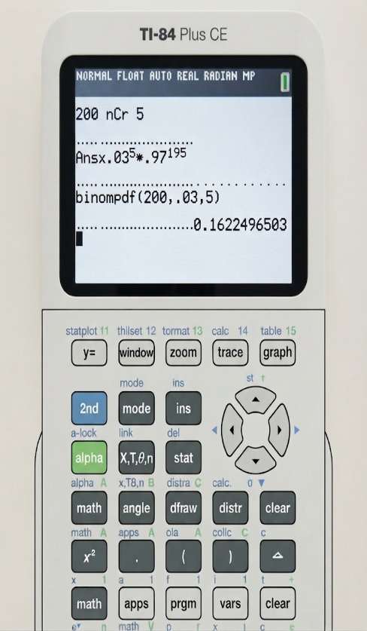
a) What are the mean and standard deviation of $X?$
$$μ_{x}=np$$
$$μ_{x}=\left(200\right)\left(0.03\right)=6$$
$$σ_{x}=\sqrt{npq}$$
$σ_{x}=\sqrt{\left(200\right)\left(0.03\right)\left(0.97\right)}=√5.82$≈ 2.41

b.) What is the probability that exactly 5 light bulbs are defective?
$P\left(X=5\right)=\left({200 \atop 5}\right){\left(0.03\right)}^{5}{\left(0.97\right)}^{200-5}=0.1622$
or $\text{binompdf}\left(200,0.03,5\right)$
c.) Find the probability that 3 or fewer light bulbs are defective.

$$P\left(X≤3\right)=P\left(X=0\right)+P\left(X=1\right)+P\left(X=2\right)+P\left(X=3\right)$$

$$=\left({200 \atop 0}\right){\left(0.03\right)}^{0}{\left(0.97\right)}^{200}+\left({200 \atop 1}\right){\left(0.03\right)}^{1}{\left(0.97\right)}^{199}+\left({200 \atop 2}\right){\left(0.03\right)}^{2}{\left(0.97\right)}^{198}+\left({200 \atop 3}\right){\left(0.03\right)}^{3}{\left(0.97\right)}^{197}$$
or $\text{binomcdf}\left(200,0.03,3\right)$

